THE OVERDALE MEDICAL PRACTICE

PATIENT PARTICIPATION GROUP (PPG)

MINUTES

Friday 1st March 2024 at 12:00 at the Breaston Surgery

Patient Representatives: Josta Gardner (Chairman), Enid Ruff (Secretary), Rob Young (Vice Chairman), Margaret Gregory (Treasurer), Sarah Richards, Ann Hope and Carol McGuffie.

Practice Representatives: Fiona Bolstridge (Practice Manager) and Carolyn Helm (I.T.)

Apologies: Dr Nick Coxon, Sheila Owens, Lynne Hare (Social Prescriber) and Mike Kerins.

Membership: We were joined by prospective patient representative Carol McGuffie.

Approval of minutes (January 2024 meeting).

Approval of minutes proposed by Sarah Richards and seconded by Margaret Gregory.

- Matters arising (from January 2024 minutes).

The committee members expressed their thanks to the practice for the convivial lunch following the AGM in February.

Re: section 3 and limited availability of appointments. Josta recounted several more examples of the appointments being completely allocated by early morning. Fiona explained the practice is under immense pressure for appointments and they are looking at ways to minimise impact. It was noted that whilst there is more demand for morning appointments and the morning clinics quickly become full, some urgent afternoon appointments tend to be available. Actions being taken to minimise impact to patients include:
- Enabling reception staff to raise eConsult cases on behalf of patients in non-urgent circumstances.
- Changing the mix of on-the-day and pre-bookable appointments.
- Encouraging patients to use pharmacy plus and urgent treatment centres when appropriate to do so.

Margaret asked if pharmacy plus staff can access patient medical records. Fiona explained that some information is available such as major diagnoses, allergies etc but not the full medical record.

Carol queried treatment for eye infections. Fiona confirmed that there is a pathway through opticians and patients are signposted when appropriate.

- Brief report from the Treasurer

There were no PPG transactions this period. Any expenditure will be authorised at the PPG meetings and recorded in the minutes.

Balance in January 2024: £105.42
Current Balance: £105.42

The NAPP membership renewal fee of £40 was agreed at the January 2024 PPG meeting and will be transacted at the end of March.

Fiona noted that the Nebuliser costs were less than the £200 donation so the difference will be added to the PPG funds. Fiona will confirm the amount with Margaret.

- Information Exchange including PPG contribution to the website and recruitment drive.

Membership

Carol McGuffie has joined this meeting as a prospective member, having registered an interest through Dr Coxon.
Rob posted on the Ockbrook and Borrowash Facebook page and two people registered their interest. Both were invited to this meeting and Rob will follow-up and invite them to the next meeting.
Prospective candidate Sarah is still interested and will hopefully join a meeting soon.

Website update

The Overdale website is being re-designed to make it more user friendly and mobile device friendly. The new design will improve ease of access to the most used features like ordering prescriptions, accessing online services, self-help, new registrations and friends and family feedback.
Fiona mentioned that some patients found the process of getting access to online services difficult, so this is being streamlined.

- Progress report on GP clinics, the GP Improvement Programme and PCN update on the Access Plan

As Fiona mentioned earlier, the practice is trying to make better use of services like eConsult, pharmacy plus and urgent care to help manage demand.
Rob mentioned that his experience of eConsult has been very good, but the warning message that it may take up to 5 days to process can be a disincentive to use the service. As Rob has experienced and Fiona explained, eConsults are generally triaged very quickly, often the same or next day. Fiona will review the wording of the time to process message.

January was an extremely busy month, and the practice reviewed how appointments were allocated. Most patients did get same day appointments, where appropriate. Those that didn’t get same day, were able to be seen in the next few days. The practice continues to offer pre-bookable appointments and extended hours appointments on some evenings and Saturday mornings.

- Correspondence: NAPP bulletins, Joined Up Care Derbyshire (JUCD) etc.

NAPP issued an ebulletin by email for February.

Enid has circulated the latest JUCD updates.

- Family and Friends feedback

We discussed the results of the feedback for January 2024 (187 responses) and February 2024 (225 responses).

Patient feedback continues to be extremely positive and 98% of respondents would recommend Overdale to friends and family.

The main themes within the many positive comments continue to be around the ease of access to appointments and the professionalism and care shown by the whole team at Overdale.

Despite most of the feedback saying that access to appointments is good, there has been a notable increase in comments from patients who have had difficulty in getting an appointment and long waits on the telephone.

From the feedback received during January and February, the chart below shows the number of times a keyword associated with various aspects of GP services is mentioned as a positive or negative experience.

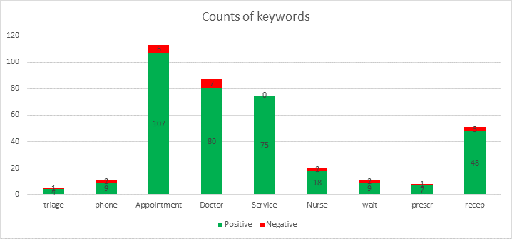

- NAPP VeryConnect Platform for PPGs.

The Department of Health and Social Care are currently holding an open consultation on the role of incentive schemes in general practice. The consultation closes on 7th March 2024.

In England, general practices are incentivised through 2 main schemes, the:

- Quality and Outcomes Framework (QOF)
- Investment and Impact Fund (IIF)

These schemes aim to enhance healthcare delivery and patient outcomes by incentivising continuous improvement in clinical care and public health delivery.

This consultation is divided into 3 sections:

- feedback on the role and nature of any incentive scheme in general practice, with a focus on the current scope of the QOF and the IIF
- comments on possible changes in scope of incentive schemes beyond clinical indicators
- input on reducing the administrative burden associated with the schemes and enhancing the clinician’s experience of delivering it

This consultation aims to gather diverse views and is open to all stakeholders, including healthcare professionals, patient groups and the wider public.

- Mental Health Issues – Adults and Children

The first group session was held on 8th February. Lynne and Lisa are looking at ways to increase participation in future sessions.
A new mental health service is coming into the area soon. It is called The Living Well Service. It is a service for adults over the age of eighteen. There is nothing at present in the pipeline for children’s mental health needs.
There followed a discussion about the effects of lockdown on children’s development, mental health and social interaction.

9. Forward Planning – Community Events

A Dementia session was held on 29th January at the Age UK building in Chaddesden.

A carer peer support meeting will be held on 6th March at St. Mary’s Hall, Draycott.

The second emotional support hub meeting will be held on 14th March at St. Mary’s Hall, Draycott.

There is no update on the planning of the next joint event with Park Medical. More information should be available at a future meeting.

10. Staffing

The practice will be interviewing shortly to replace a member of the administration team.

- Storage of PPG Minute Files

Josta gave a very interesting history of the Overdale PPG, from its inception in 2003.

Josta explained that there are 4 folders comprising all documentation associated with the PPG, that are currently in her possession. Josta would prefer these to be stored and possibly archived in a way that better preserves this historical record.

The committee discussed the option of local historical groups but considered it unlikely to be subject matter they’d be interested in holding.

Fiona said the practice could hold the files but wouldn’t be able to guarantee protection from accidental disposal.

The committee began to consider options for electronic archiving but was unable to conclude the discussion due to time constraints. This topic will be an agenda item at our next meeting.

- AOB

Nothing to report.

The next PPG meeting will be at Noon, Friday 3rd May 2024 at the Breaston Surgery.

