THE OVERDALE MEDICAL PRACTICE

PATIENT PARTICIPATION GROUP (PPG)

MINUTES

Friday 12th January 2024 at 12:00 at the Breaston Surgery

Patient Representatives: Josta Gardner (Chairman), Enid Ruff (Secretary), Rob Young (Vice Chairman), Mike Kerins, Ann Hope and Sarah Richards.

Practice Representatives: Fiona Bolstridge (Practice Manager), Dr Nick Coxon and Carolyn Helm (I.T.)

Apologies: Margaret Gregory (Treasurer), Sheila Owens and Lynne Hare (Social Prescriber)

Membership: No changes to report.

Approval of minutes (November 2023 meeting).

Approval of minutes proposed by Sarah Richards and seconded by Enid Ruff.

- Matters arising (from November 2023 minutes).

Shingles vaccination update:
The Covid and flu vaccinations had earlier been prioritised over the shingles vaccinations but these are now well on track. Patients will be called at the point of turning 65 years, or 70 years if already over 65. Additionally, clinically vulnerable adults of any age may receive the Shingles vaccination.

- Brief report from the Treasurer

There were no PPG transactions this period. Any expenditure will be authorised at the PPG meetings and recorded in the minutes.

Balance at November 2023: £105.42
Current Balance: £105.42

Josta mentioned the upcoming annual NAPP membership renewal will be due in March. We agreed this will be renewed through PPG funds.

- Concerns about prospective patients using incorrect addresses to register with Overdale

This issue was discussed at a partners meeting. It was agreed that new patients will be asked for ID and proof of address as part of the registration process going forward.

- Information Exchange including PPG contribution to the website and recruitment drive

Josta queried an observation she had made when all available appointments appeared to have been filled by 9.15am. Fiona explained that it is often the case that appointments are booked quickly but emergency appointments are normally still available. Nick explained how that today, for example, slots were still available at the time of the meeting. Appointment availability is constantly under review to ensure patients can be seen promptly. On the rare occasion that all morning appointments are filled, a patient may be asked to call back in the afternoon but would not be required to repeat the triage process unless it wasn’t carried out that morning.

Nick explained that due to this winter surge in covid and flu cases, additional PCN funding has been allocated for GP surgeries to operate ‘acute respiratory infection hubs’. In response, Overdale has scheduled extra clinics dedicated to respiratory illnesses which involves 3 partner GPs providing 9 extra clinics.

Membership

We are actively seeking new PPG members. Nick provided details of a potential new member to Fiona for follow-up and Rob has invited a potential new member to join us at the meeting in March.

Rob hasn’t yet posted an appeal on Facebook, but following discussion it was felt that we may attract greater diversity into the PPG by attempting this.

Mike expressed hope that we could attract younger patient representatives into the group. Sarah explained that whilst it may be more difficult to recruit working patient representatives, many employers allow paid time off for voluntary work within the community and being a member of the PPG would qualify.

- Progress report on GP clinics, the GP Improvement Programme and PCN update on the Access Plan

An initial review has been completed and has resulted in some positive changes. Some examples include protection of clinics on Mondays and Tuesdays to prevent over-booking, introduction of GP pre-bookable appointments for easier follow-up and a better spread of physio clinics during the week.

The next review will look at triage and minor illness booking and will take place in the coming weeks.

The NHS App is being promoted as a way of enhancing the patient experience. Many patients are already using Systm1 and currently there is little difference in the information or services that can be accessed by using either system.

The PCN 5 year cycle comes to an end in March. It is not known if there will be any changes to the contract, but no significant changes are expected under the current circumstances.

- Correspondence: NAPP bulletins, Joined Up Care Derbyshire (JUCD) etc.

Nothing to report this period.

- Family and Friends feedback

We discussed the results of the feedback for November 2023 (208 responses) and December 2023 (162 responses).

Patient feedback continues to be extremely positive and 99% of respondents would recommend Overdale to friends and family.

The main themes within the many positive comments continue to be around the ease of access to appointments and the professionalism and care shown by the whole team at Overdale.

We discussed the rate of increase in new patient registrations. This has slowed down in recent weeks. It should be noted that whilst clinical staff resources can be flexed to meet patient demand to a certain extent, the physical capacity of the GP surgeries cannot be increased any further.

From the feedback received during November and December, the chart below shows the number of times a keyword associated with various aspects of GP services is mentioned as a positive or negative experience. Out of 370 comments received for the period, there was no evidence of any existing or emerging systemic concerns.

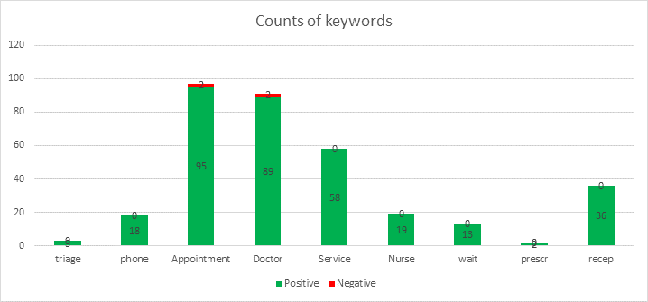

- NAPP VeryConnect Platform for PPGs.

Rob summarised a debate on the platform where PPGs were asked if a GP routinely took part in PPG meetings. Most of the respondents indicated that a GP never or rarely participated in their meetings and the practice would typically be represented by the practice manager or deputy manager. Overdale appears to be a rare example where a GP always participates, along with the Practice Manager, Social Prescriber, IT and other roles as appropriate. We have found that having the support of the practice staff at the PPG meetings adds enormous value to the discussions and demonstrates a healthy relationship between the PPG and the practice.

- Mental Health Issues – Adults and Children

The Social Prescribers and our Mental Health Nurse Practitioner, Lisa, are developing a new emotional support hub. Posters are being printed and will be displayed in both surgeries. The first group meeting will be held on 8th February in Draycott.

10. Forward Planning – Community Events

A positively received quarterly carers’ group meeting was held in December. The next one will be held in March.

A Dementia session aimed at carers is planned for 29th January at the Age UK building in Chaddesden.

A joint event is being planned with Park Medical and will be supported by the Social Prescribing team amongst others. This was last held on a Saturday and was extremely well attended.
Mike asked about whether this may be an opportunity to raise awareness of prostate issues. Nick mentioned that there has been some targeted funding at Derby City level to try and raise awareness on this topic.

11. Staffing

No changes to report this period.

- Preparation for the AGM on Friday 2nd February 2024

The PPG agreed the date and agenda, and previous minutes will be circulated shortly. Thanks to Carolyn as the AGM has already been publicised on the website.

- Dates for committee meetings in 2024

The PPG have agreed the proposed dates for committee meetings in 2024. They are planned to be the first Friday of alternate months. A meeting date may change if circumstances dictate nearer the time.

- 2nd February 2024 AGM
- 1st March 2024
- 3rd May 2024
- 5th July 2024
- 6th September 2024
- 1st November 2024
- 10th January 2025

- AOB

Nothing to report.

The next PPG meeting will be the AGM at 12 Noon on Friday 2nd February 2024 at the Breaston Surgery.

