THE OVERDALE MEDICAL PRACTICE

PATIENT PARTICIPATION GROUP (PPG)

MINUTES

Friday 3rd May 2024 at 12:00 at the Breaston Surgery

Patient Representatives: Josta Gardner (Chairman), Enid Ruff (Secretary), Rob Young (Vice Chairman), Margaret Gregory (Treasurer), Sarah Richards, Ann Hope and Carol McGuffie.

Practice Representatives: Fiona Bolstridge (Practice Manager), Dr Nick Coxon and Carolyn Helm (I.T.)

Apologies: Sheila Owens, Lynne Hare (Social Prescriber) and Mike Kerins.

Membership: See agenda item 5

Approval of minutes (March 2024 meeting).

Approval of minutes proposed by Sarah Richards and seconded by Margaret Gregory.

- Matters arising (from March 2024 minutes).

Fiona has an outstanding action to confirm remaining funds from the nebuliser donation.

eConsult prospective change to wording about 5 days to process. Fiona emphasised that eConsults should only be used for non-urgent queries. Although the warning notice states up to 5 days to process, they are normally reviewed within a few hours. Any follow-up appointment or task raised in response to an eConsult is not considered urgent. Rob believes that the 5 days to process warning discourages people to use this service, even for non-urgent queries and does not reflect the fact that they are usually processed faster than that.
Fiona explained that there are on average 6 eConsults raised per day. Consideration will be given to amending the 5 days to 3-5 days and will be kept under review.
Margaret asked if any acknowledgement of receipt of an eConsult is sent to the patient. Fiona explained that the system confirms successful submission at the time the eConsult is raised but any further contact with the patient would have to be done manually.

- Brief report from the Treasurer

Any expenditure is authorised at the PPG meetings and recorded in the minutes.

There was 1 PPG transaction this period.

Balance in March 2024: £105.42
NAPP Membership renewal -£40
Current Balance: £65.42

Our NAPP membership was renewed on 31st March 2024. Rob has forwarded the receipt to Fiona for reimbursement through PPG funds which is reflected in the balance this period.

The Nebuliser costs were less than the £200 patient donation so the difference will be added to the PPG funds. Fiona will confirm the amount with Margaret.

- Preserving PPG Minute Files

Josta is the current custodian of 4 folders comprising all documentation associated with the PPG since its inception in 2003. These ideally need to be stored and possibly archived in a way that better preserves this historical record.

Josta emailed the Deputy Library Knowledge Service Manager and Medical Museum Curator for Derby and Burton Hospital Trust. A reply was received and offered a couple of options to consider.
One was for the practice to consider purchasing a lockable display cabinet to store the folders. This would prevent accidental disposal. The second option was to donate the archive to a local studies library who may be able to archive the notes electronically online.
Margaret mentioned the Breaston History group may be interested in a digital copy but wouldn’t be able to hold the physical copies.

Sarah offered to scan the documents to create digitised copies and then the old physical documents could be allocated to any interested parties. Sarah will liaise with Josta.

Margaret mentioned she has all the Treasurers reports but not sure if it would be of interest. Financial summary information is also routinely recorded in the PPG minutes. We agreed we could review what to do with the financial reports at a later date.

- Information Exchange including PPG contribution to the website and recruitment drive.

Medical Research

Overdale is now a Level 4 Research site (entry level) and recently participated in the FeNo machine trial as part of a research project. It was well received by patients. By becoming a research practice, there will be more opportunities to get involved with similar new studies. One example under consideration is a research project looking into post-cancer treatment follow up.

Dr Joshi is the lead GP on behalf of the practice and the priority is to be mindful of probity and ensuring the value of participating in research for the benefit of patients. The practice will also benefit in a small way financially for participating in research activities. One of the research project administrators, Bradley, may be able to attend a future PPG meeting. Bradley is currently working with the practice to make a patient communication about Overdale becoming a research practice.

Membership

Carol McGuffie is now a member of the PPG.

New candidate member Sarah was unable to join this meeting but hopes to attend the July meeting.

Website update

The Overdale website has been re-designed to make it more user friendly and mobile device friendly. The response has been positive. Carolyn welcomes any comments or ideas for further improvement.

- Progress report on GP clinics, the GP Improvement Programme and PCN update on the Access Plan

Fiona explained that primary care pressures are extremely high but Overdale is managing well compared to most GP practices. There is an insatiable demand due to other parts of the healthcare system not working well.

Nick explained how Overdale had significantly increased its appointment capacity to try and respond to the unprecedented demands. Comparing the last two years:
- The Primary Care Network (comprising Overdale and Park Medical practices) issued an additional 11,500 appointments, 8,500 of which were provided by Overdale.
- In 2023, Overdale provided 16,000 more face to face appointments than the previous year, giving a total of 85,000 appointments.
- There are 11,790 patients currently registered with Overdale, compared to just over 11000 in May 2022.

The PCN Action plan (April to March) has remained the same for this year and is expected to remain unchanged as there is likely to be a General Election by year end.

- Correspondence: NAPP bulletins, Joined Up Care Derbyshire (JUCD) etc.

NAPP issued an ebulletin by email on 27th March 2024.

Enid has circulated the latest JUCD updates.

- Family and Friends feedback

We discussed the results of the feedback for March 2024 (240 responses) and April 2024 (227 responses).

Patient feedback continues to be extremely positive and 97% of respondents would recommend Overdale to friends and family.

The main themes within the many positive comments continue to be around the ease of access to appointments and the professionalism and care shown by the whole team at Overdale.

Despite most of the feedback saying that access to appointments is good, there has been a notable increase in comments from patients who have had difficulty in getting an appointment and long waits on the telephone. Fiona explained that March was a particularly challenging month (feedback reflected in April), that included some resource constraints, and is expected to be a blip. It is also worth noting that despite the challenging demands placed on the practice, patient satisfaction remains remarkably high at 97%.

From the feedback received during March and April, the chart below shows the number of times a keyword associated with various aspects of GP services is mentioned as a positive or negative experience.

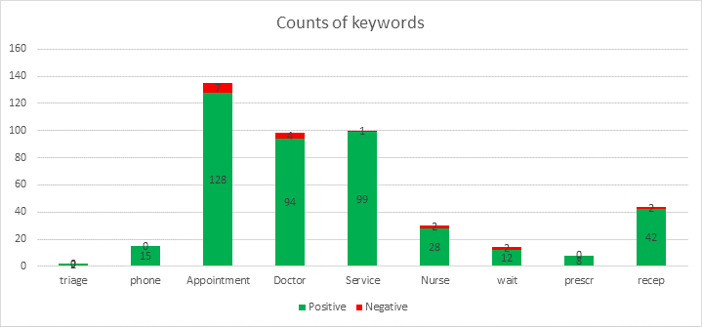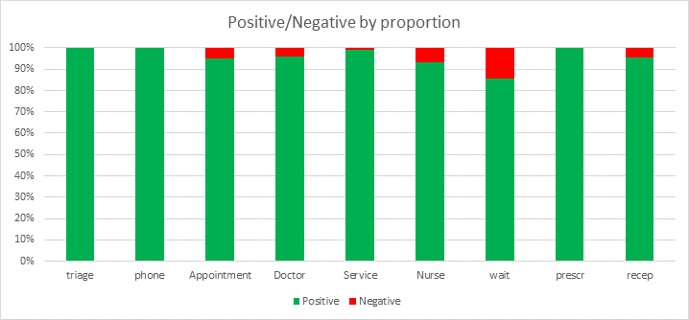

- NAPP VeryConnect Platform for PPGs.

A document - 'PPG Guide - One size does not fit all' has been uploaded to the VeryConnect platform. Many of the key recommendations for having an effective PPG are already in place at Overdale.

PPG Awareness Week will be 3-9 June 2024 and is about sharing best practice amongst PPGs.

NAPP Membership fees have increased from £40 to £60 from 1st April 2024.

- Mental Health Issues – Adults and Children

No update this period.

10. Forward Planning – Community Events

There will be a Health and Wellbeing Event, hosted by Park Medical and Overdale at the Methodist Church Hall in Borrowash on Saturday 8th June 2-4pm. Posters have been produced and circulated.

11. Staffing

The administration post has been filled and the new member of staff is settling in well.

- AOB

Nothing to report.

The next PPG meeting will be at Noon, Friday 5th July 2024 at the Breaston Surgery.

