THE OVERDALE MEDICAL PRACTICE

PATIENT PARTICIPATION GROUP (PPG)

MINUTES

Friday 10th January 2025 at 12:00 at the Breaston Surgery

Patient Representatives: Josta Gardner (Chairman), Rob Young (Vice Chairman), Margaret Gregory (Treasurer), Carol McGuffie, Sarah Richards, Mike Kerins and Sheila Owens.

Practice Representatives: Fiona Bolstridge (Practice Manager), Carolyn Helm (I.T.), Lisa Kenny (Mental Health Practitioner) and Dr Nick Coxon.

Apologies: Enid Ruff (Secretary)

Ann Hope did not attend and did not send apologies

Membership: No changes this period.

Mental Health Practitioner Lisa Kenny joined the meeting to reintroduce herself and provide an update on mental health services. See section 10.

Approval of minutes (November 2024 meeting).

Approval of minutes proposed by Sarah Richards and seconded by Margaret Gregory.

- Matters arising (from November 2024 minutes).

Josta suggested we review the spending policy for the PPG at the next meeting.

A community event was held in December, although not very well attended.

- Brief report from the Treasurer

Any expenditure is authorised at the PPG meetings and recorded in the minutes.

Balance at November 2024: £246.84
No transactions this period.
Current Balance: £246.84

Margaret requested a list of transactions. Fiona will pass the request on.

- Industrial Action

Nick advised that key stakeholders are awaiting news on the next GP contract and there are no further updates at present.

- Information Exchange including PPG contribution to the website and recruitment drive.

Sarah has been reviewing the old PPG material for digitising. Sarah will meet separately with Josta and Rob to finalise the approach.

A new Overdale newsletter was published today on the Overdale web site.

- Progress report on GP clinics, the GP Improvement Programme and PCN update on the Access Plan

Digital triage processes are being looked at as part of NHS England proposals. The intention is to develop new ways to help direct patients to the right help at the right time.

A new cloud-based telephone system is planned for installation in week commencing 10th February.

- Correspondence: NAPP bulletins, Joined Up Care Derbyshire (JUCD) etc.

NAPP issued an ebulletin by email on 23rd December 2024.

Enid has circulated the latest JUCD updates.

- Family and Friends feedback

We discussed the results of the feedback for November 2024 (202 responses) and December 2024 (167 responses).

Patient feedback continues to be extremely positive and 98% of respondents would recommend Overdale to friends and family.

The main themes within the many positive comments continue to be around the ease of access to appointments, and the caring person-centred approach shown by the whole team at Overdale.

There were several negative comments expressing frustration at receiving text message invitations to provide feedback. Mike recommended that as soon as the systems allow, to enable people to opt out of receiving text messages for surveys.

There was also a point of feedback received raising concerns about how an emergency prescription request was handled. This was discussed and the practice representatives explained how such a request would be managed.

From the feedback received during November and December, the chart below shows the number of times a keyword associated with various aspects of GP services is mentioned as a positive or negative experience. There is no evidence to indicate any emerging or systemic concerns.

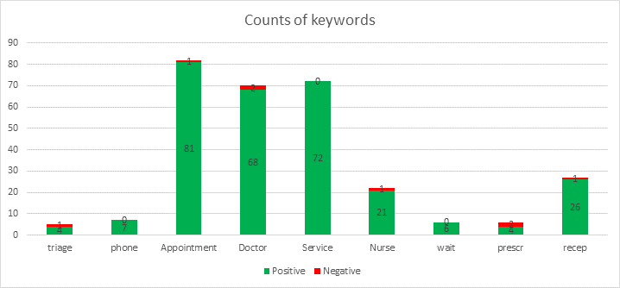

- NAPP VeryConnect Platform for PPGs.

The NAPP Annual General Meeting was held on Saturday 16th November 2024, attended virtually by Josta, Enid and Rob.

The NAPP organisation has been struggling to provide anything of value to established PPGs in recent years. Rob asked that we discuss whether or not our membership should be renewed from the end of March at the next PPG meeting. Rob will share his thoughts and alternative options prior to the March PPG meeting.

- Flu/Covid vaccinations. How did we do?

Flu clinics have operated well, and most people have been taking up both the flu and covid vaccines at the same time. There is still demand for this service, so appointments are still being provided.

- Mental Health Issues – Adults and Children

Lisa Kenny is a Mental Health Practitioner, providing mental health support services to Overdale’s patients as part of the Oakdale PCN.

Lisa has been with Overdale for the last 16 months, working with 18-65 year olds. She explained that there continues to be huge demand for mental health services. Significant delays are being experienced by patients on the ADHD and ASD pathways awaiting assessment and treatment. Delays of months and years in some cases are significantly impacting people’s lives.

There are around 15 MHPs providing services across Derbyshire GP surgeries and Derby City have recently benefited from the assignment of a new mental health consultant to oversee services.

We talked through how the MHP role supports the GP practice and helps patients. When a patient contacts the GP surgery, the usual triage applies to understand the nature and urgency of the problem. Our MHP has a number of appointment slots available to meet with patients, but this can be up to two weeks. If the problem is urgent, an appointment will be made with a GP the same day where possible. In cases of mental health emergency, the patient will be referred to the Crisis team.

- Forward Planning – Community Events

A PCN level event at Ashbrook community centre in January is being planned.

Age UK organising a women’s health event in Chaddesden. Details will follow on the Overdale web site.

- Staffing

Two new receptionists are joining the team - Roopan has started and Jade will be starting shortly.

Fiona and Kelly are leaving the practice today. Carolyn Helm has become Practice Manager and has recruited a new Operations Manager who will start in the Spring.
The PPG are very sorry to be losing Fiona and Kelly from the practice and are grateful for the all the positive support given to the PPG over the years. We wish them both the very best for the future. The committee congratulated Carolyn on her promotion and we hope to continue the great relationship built between the practice and PPG for the benefit of all Overdale patients and staff.

- AOB

Nothing to report.

The next PPG meeting will be the AGM at Noon on 7th February 2025 at the Breaston surgery.

Dates for meetings in 2025: 7th March, 9th May, 4th July, 5th September, 7th November and 9th January 2026.

