THE OVERDALE MEDICAL PRACTICE

PATIENT PARTICIPATION GROUP (PPG)

MINUTES

Friday 7th March 2025 at 12:00 at the Breaston Surgery

Patient Representatives: Josta Gardner (Chairman), Rob Young (Vice Chairman), Enid Ruff (Secretary), Margaret Gregory (Treasurer), Carol McGuffie, Sarah Richards, Mike Kerins and Sheila Owens.

Practice Representatives: Carolyn Helm (Practice Manager), and Dr Nick Coxon.

Apologies: Ann Hope did not attend and did not send apologies. Josta has attempted to contact Ann with no success.

Membership: No changes this period.

Approval of minutes (January 2025 meeting).

Approval of minutes proposed by Sarah Richards and seconded by Sheila Owens..

- Matters arising (from January 2025 minutes).

No matters arising.

- Brief report from the Treasurer

Any expenditure is authorised at the PPG meetings and recorded in the minutes.

Balance at January 2025: £246.84
No transactions this period.
Current Balance: £246.84

PPG funds are held with the Practice. Margaret had requested a list of PPG transactions for verification purposes. A spreadsheet had been provided but did not appear to relate to PPG expenditure. Carolyn will look into it.

- Shall we continue our membership of NAPP?

Our membership of the National Association for Patient Participation is due for renewal at the end of March 2025. The annual subscription has doubled since last year from £40 to £80.

NAPP have struggled in recent years to retain a quorum of trustees and resources in order to deliver any meaningful support to PPGs. Rob and other members of the PPG have had increasing concerns about the value of maintaining the membership.

The main benefit of membership is having access to the VeryConnect web portal which provides access to PPG related guides and documentation. The resources are largely focused on establishing and building an effective PPG. Overdale PPG is already a long-established PPG and operates very well, by any measure offered in the NAPP guides for good practice.
The discussion group aspect of VeryConnect offers the ability to raise questions and share information with other PPGs, however this feature is not well used, so offers minimal value.

If Overdale choose not to renew the membership, we would lose access to the VeryConnect platform and we would have to remove signage on the noticeboards about affiliation to NAPP.

Rob recommended we do not renew our NAPP membership this year. There are alternative sources of information and guidance for PPGs that do not require subscription. For example, the Patients Association is an independent patient charity campaigning for improvements in health and social care for patients. They recently completed a project supporting patient engagement and revitalising PPGs. A report is available on the Patients Association web site at https://www.patients-association.org.uk/

Margaret proposed we leave NAPP – the committee voted and agreed to cancel membership and not renew. Rob will cancel NAPP membership renewal for 2025. Action Carolyn to remove NAPP affiliation from noticeboards at Borrowash and Breaston sites by 1st April 2025.

Mike asked how we might get involved directly with Patient Association activities. Mike suggested PPG committee members all take some time to review the Patients Association web site https://www.patients-association.org.uk/

- Information Exchange including PPG contribution to the website.

A new telephone system was installed in February. Some members of the PPG had experienced using it and some features like call-back are welcome. There were reports that the welcome greeting doesn’t appear to be working. Carolyn is looking into it.

A Spring Covid booster campaign is starting from 1st April for adults over 75, care home residents and immune-suppressed patients.

- Correspondence: NAPP bulletins, Joined Up Care Derbyshire (JUCD) etc.

NAPP issued an ebulletin by email on 12th February 2025.

Enid has circulated the latest JUCD updates.

- Family and Friends feedback

We discussed the results of the feedback for January 2025 (199 responses) and February 2025 (213 responses).

Patient feedback continues to be extremely positive and 97% of respondents would recommend Overdale to friends and family.

The main themes within the many positive comments continue to be around the ease of access to appointments, and the caring person-centred approach shown by the whole team at Overdale.

A number of feedback items (8 in January and 1 in February) have been excluded from the analysis as they were just profanities and not genuine feedback.

There were several negative comments by patients who had experienced difficulty in getting an appointment. One notable comment referred to how easy it had been in the past and more recently has become much more difficult. However, the majority of feedback remarks on the ease of getting an appointment when needed.
Nick illustrated the challenges around demand for appointments with some results from a recent audit. For one week in January 2025, there were 40% more patient contacts than in the same week in 2018. In one week in January 2025 there were 1020 appointments delivered with no appointments spare compared to 2018 when there were 869 appointments, 147 which were spare and not used.

Two comments (likely both from same patient) raised a concern that reception are ‘giving a diagnosis and telling patients what to do’.
The receptionists play a vital role in helping the patient get the appropriate help they need. The vast majority of feedback that mentions the receptionist role is positive in nature. As part of improvements being planned, Artificial Intelligence will play an increasing role in triage processes that will take some of the responsibility away from receptions for first level filtering.

From the feedback received during January and February, the chart below shows the number of times a keyword associated with various aspects of GP services is mentioned as a positive or negative experience. There is no evidence to indicate any emerging or systemic concerns.
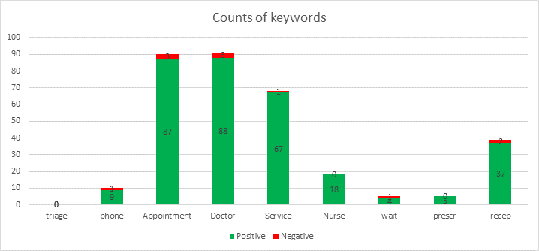

- Distribution of hard copy of spending policy

Josta handed out a copy of the spending policy for review and will be discussed at the next PPG meeting

- AOB

Nothing to report.

The next PPG meeting will be at Noon on Friday 9th May 2025 at the Breaston surgery.

Post-meeting minute
Sarah, Josta, Enid and Rob met on 15th March to discuss the digitising of old PPG minutes and next steps.
Sarah has scanned all but the most recent 2 years of Overdale PPG meeting agendas, meeting minutes and related information into PDF format. 116Mb of data is stored on a USB pen drive and is organised in folders by decade.
Next steps:
- Josta will discuss with her contact at the local historical society to see if they would like a copy.
- Margaret had offered to provide the financial documents for digitising. Sarah is happy to do this for us and we’ll discuss this at the next PPG meeting.
- The hardcopy minutes files have been returned to Josta for either storage or disposal. Sarah has offered to take them for shredding and recycling if required.
- Rob is the currently the custodian of the electronic records – copies can be made for anyone interested.
- Rob will periodically update the archive as necessary.
Josta, Enid and Rob thanked Sarah for her efforts in digitising the PPG documentation. It is much appreciated.

