THE OVERDALE MEDICAL PRACTICE

PATIENT PARTICIPATION GROUP (PPG)

MINUTES

Friday 9th May 2025 at 12:00 at the Breaston Surgery

Patient Representatives: Josta Gardner (Chairman), Rob Young (Vice Chairman), Carol McGuffie, Sarah Richards, Mike Kerins and Ann Hope.

Practice Representatives: Dr Nick Coxon.

Apologies: Carolyn Helm (Practice Manager), Enid Ruff (Secretary), Margaret Gregory (Treasurer) and Sheila Owens.

Membership: No changes this period. Andrew Carson has recently started as Assistant Practice Manager at Overdale.

Approval of minutes (March 2025 meeting).

Approval of minutes proposed by Sarah Richards and seconded by Nick Coxon.

- Matters arising (from March 2025 minutes).

No matters arising.

- Brief report from the Treasurer

It was discovered in an audit that the payment for the John Lewis gift for Simon Gregory’s retirement had not been taken from PPG funds but from a different fund in the Practice Accounts.
This oversight has now been rectified and our PPG Account has been debited by £50.00 and repaid to the Practice Account.

Balance at March 2025: £246.84
Simon Gregory retirement John Lewis gift : - £50
Current Balance: £196.84

PPG funds are held with the Practice. Any expenditure is authorised at the PPG meetings and recorded in the minutes.

- Update on Doctors’ action

Nick gave an update on Doctors’ potential industrial action. A recent report by the BMA described general practice as imminent for collapse across the country.
At a recent meeting with Chris Clayton .Chief Executive of NHS Derbyshire..Nick explained that there have been large cutbacks in funding across NHS services, except for GP practices. There is a strong focus on waiting list reduction. Recent GP action had stopped supporting advice requests as part of collective action, but in reality are now incentivised and doing more advice requests to help reduce waiting lists!

Nothing notable in terms of collective action is happening at county or national level and GPs are awaiting publication of the 10 year plan, where it is expected that primary care may receive an increase in funding. Primary healthcare was allocated 12% of the total health budget in the late 1990s, but this has reduced over time to currently 8% and the hope is to get nearer 10%.

Nick mentioned how Andy Burnham recently spoke about having health as an agenda item in all areas of leadership and planning from his experience as Mayor of Manchester; the idea being to give emphasis on preventative and proactive approaches to health, not just treating when sick.

- Information Exchange including PPG contribution to the website.

There is a new link to Rapid Health added to the Overdale website which is a new online appointment booking system with digital triage.

The new telephone system was installed in February which is being rolled out nationally at all GP surgeries. Some features have been welcomed by patients, like call-back which enables you to hang up and retain your place in the queue and receive a call when it is your turn. There have been some reports of call drop-outs which can be frustrating for patients.
Nick explained that statistics provided by the new system indicates that GP surgeries receive 50 million telephone calls per month (weekdays only) across England. This is an astonishing number of calls to handle. It is hoped that Rapid Health online booking and triage will help to alleviate some of the pressures on the telephone contact approach.

- Report on GP clinics, GP Improvement programme and PCN update

Nick explained that there will be neighbourhood working under the 10 year plan, where GP surgeries will work more closely with others at a local level. We are in a good position as our PCN already works well with the greater Derby area and makes an ideally sized 150K patient service neighbourhood.

The frailty services project is one example of a working team of visiting services to provide more proactive services for the elderly. The focus is on providing preventative and timely interventions that reduce falls and expensive hospital admissions.

GP clinics have been particularly challenging over these winter months. Nick explained that he has never experienced a winter period where there has been such a high level of clinician sickness. This has led to prolonged periods of increased pressure on clinicians working extra time to cover sickness absence. This issue, combined with unprecedented demands on GP surgeries, has inevitably affected appointment availability in recent months.
The additional clinical roles that now exist within the practice are actively helping to reduce direct pressure on GPs, whilst still providing the optimum care to patients.

The patient population at Overdale has just ticked over 12,000. The current prediction is this number will remain relatively stable for the foreseeable future. It is planned that additional GP clinics will be available from August.

- Correspondence: NAPP bulletins, Joined Up Care Derbyshire (JUCD) etc.

Enid has circulated the latest JUCD updates.

- Family and Friends feedback

We discussed the results of the feedback for March 2025 (160 responses) and April 2025 (170 responses).

Patient feedback continues to be extremely positive and 97% of respondents would recommend Overdale to friends and family.

The main themes within the many positive comments continue to be around the ease of access to appointments, and the caring person-centred approach shown by the whole team at Overdale.

There are signs in the feedback that suggest it is becoming more difficult to get appointments. This is reflected in not only the negative feedback, but also in the positively rated feedback comments.
The majority of feedback regarding appointment availability remains positive, and certainly excellent when compared to many other GP practices. However, it is the duty of the PPG to raise this as a potential concern.
Nick explained earlier in the meeting the main issues that have affected GP clinics recently (in section 5) and how they are being addressed.

From the feedback received during March and April, the chart below shows the number of times a keyword associated with various aspects of GP services is mentioned as a positive or negative experience. There is some evidence to suggest there is an emerging concern regarding appointment availability.

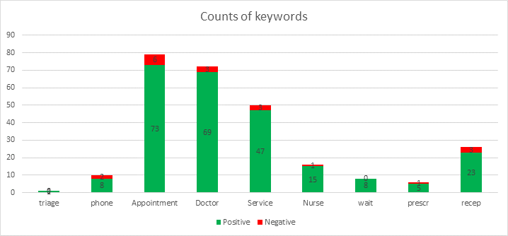

- PPG spending policy

This item is deferred to the next meeting when the Treasurer will be in attendance.

- Covid vaccinations – April 2025 Roll-out

The recent roll-out of Covid vaccinations for over 75s and immuno-suppressed patients has been completed.

- Mental Health Issues – Adults and Children

Our mental health nurse, Lisa Kenny, has made very positive impact in working with patients with ADHD. A new service is coming to Derby for ADHD diagnosis and management and is expected to start in the near future.

- Forward planning and Community events

Dr Burnett at Park Medical is studying health in deprived areas and looking at increasing PCN level community health events.
There is also going to be a significant focus on monitoring and treating blood pressure and cholesterol-related issues.

- Staffing

Doctor Day has retired. A new doctor has been appointed who will start in August. An additional GP will be starting in August supporting the PCN and providing more clinical appointments for Park Medical and Overdale.

Andrew Carson has started as Assistant Practice Manager.

Wendy has joined as Recall Administrator, replacing Jen Burton.

- Digital Triage

Overdale is working hard to be part of the early implementation of the digital triage system, Rapid Health. This is being introduced to try to eliminate the 8:30am and 13:30pm rush on the phones, reduce the telephone queue and ultimately help with the difficulty of booking appointments with the appropriate clinicians.

- AOB

Mike made a point about medication blister packaging typically not being recyclable. He had heard about Boots chemist trialling a repository and recycling service for patients. Sarah mentioned that Asda also have a similar facility. It was proposed that recycling facilities such as this could be communicated on the Overdale website.
Nick mentioned there are green policy advancements in progress to improve recycling of clinical waste from the GP surgery.

The next PPG meeting will be at Noon on Friday 25th July 2025 at the Breaston surgery.

