THE OVERDALE MEDICAL PRACTICE

PATIENT PARTICIPATION GROUP (PPG)

MINUTES

Friday 6th February 2026 at 12:00 at the Breaston Surgery

Patient Representatives: Josta Gardner (Chairman), Rob Young (Vice Chairman), Enid Ruff (Secretary), Sheila Owens, Sarah Richards, Carol McGuffie, and Valerie Lambert.

Practice Representatives: Carolyn Helm (Practice Manager), and Andrew Carson (Operations Manager).

Apologies: Margaret Gregory (Treasurer), Mike Kerins and Dr Thomas Edwards. Ann Hope was not present and did not send apologies.

Membership: No changes this period.

Approval of minutes (November 2025 meeting).

Approval of minutes proposed by Sarah Richards and seconded by Sheila Owens.

- Matters arising (from November 2025 minutes).

Jane Ward, Assistant Practice Manager at Derby Road Health centre in Nottingham was hoping to join our PPG meeting today but was unable to attend this time. She intends to join the meeting in May.

Staffing in reception. Carolyn has recruited a new reception team leader, Melanie Scattergood who started on 12th January.

Progress of revising the disabled parking lines at Borrowash. Inclement weather has prevented progress to date, but it will be addressed as soon as practicable.

- Brief report from the Treasurer

Margaret has contacted Josta by email and intends to resign as Treasurer but would like to remain on the committee. Sarah has agreed to take on the role of Treasurer on a temporary basis.

There have been no transactions this period.

Balance in November 2025: £196.84
Current Balance: £196.84

PPG funds are held with the Practice. Any expenditure is authorised at the PPG meetings and recorded in the minutes.

- Information Exchange.

Rob, on behalf of Borrowash in Bloom, offered Overdale an opportunity to sponsor a planter in the village. Carolyn will discuss with the partners and feedback to Rob.

- Rapid Health Introduced on 22nd September – Progress Report

The nationally implemented Rapid Health on-line triage and booking system continues to be problematic for patients and staff at Overdale. Whilst there has been some positive feedback from patients, the majority report a negative experience using this system. There are also significant clinical and management issues which are reducing access to patients.

The Practice has taken the decision to move away from Rapid Health and is in discussions with the Integrated Care Board. Online appointment access between 8am and 6.30pm for non-urgent appointments requirement must be met. The hope was that the implementation of Rapid Health would reduce the length of the phone call queue. This has not happened. It was hoped that more patients would be able to use the online system, but again, more patients have struggled. The expectation was to increase access, but the opposite has been the case.

It is currently taking one Full-time Equivalent (Doctor or ANP) to manage the Rapid health inbox. Overdale partners believe it to be unsafe, with some requests coming through as green (non-urgent) but are indicating more serious conditions. The new system is also believed to be putting too much pressure on receptionists; decision-making and detail that should be dealt with by clinical professionals only.

It is not possible to quickly remove the new system, and any replacement still has to meet all the ICB requirements. The Practice is considering reverting back to SystemConnect, but with some additional customisation of templates to include ‘better’ triage questions. There may still be some challenges, but no urgent cases will be going through online or email. If booking a non-urgent appointment online, there will be questions like ‘is it a new issue or ongoing?’ and will include the ability to say who you saw previously, to better enable continuity of care. This was an aspect highly valued by patients and doctors at Overdale that has unfortunately been lost with the new system.

There have been no formal communications to date as the Practice is taking the time necessary to get the replacement right and meet the ICB criteria. Carolyn also explained that Overdale is not currently able to be compliant with online access for the full time period 8am-6.30pm as the demand is too high. At the same time, whilst the volume of phone calls has reduced, the length of time per call has increased.

For wider context, many practices in the Derby area are using RapidHealth and some are unhappy and concerned. Andrew explained that Overdale management, including Dr Edwards, met with Adam Thompson, MP for Erewash on 16th December, to raise issues around contract change and Rapid Health. It was a productive meeting, the MP took note of the challenges and promised to feed them back to the Health Minister.

- Family and Friends feedback

We discussed the results of the feedback for November 2025 (198 responses), December 2025 (149 responses) and January 2026 (183 responses).

Patient feedback is generally positive, and 86% respondents would recommend Overdale to friends and family (a 1% decline since the previous period)

The main themes within the positive comments are related to clinical service delivery being exceptionally good and the caring person-centred approach shown by the whole team at Overdale.

There continues to be an increase in the feedback of instances where patients are struggling to get an appointment, struggling to use the Rapid Health system and experiencing long waits on the telephone. However, there are still many patients who say they can get an appointment when they need one.

Rob explained that the true impact of Rapid Health would only be seen in the feedback from November 2025 onwards. Whilst this did cause a decline in patient satisfaction, it was not as significant as initially feared.
However, patient satisfaction had significantly reduced (by more than 5%) even before the introduction of Rapid Health, notably May to September.
Carolyn explained that during those months, The Practice was managing some difficult challenges in meeting increasing patient demand. There had also been the loss of some key members of the team and there had been extensive use of locum doctors. Carolyn believes that following some very positive recruitment and organisation, many aspects of practice services are in a much better position and anticipates that when Rapid Health is replaced, we will see patient satisfaction return to the exceptionally high levels consistently achieved in previous years.

It should also be kept in mind that despite the challenges, the reduction in overall patient satisfaction has been limited to 10%, and that still almost 9 out of 10 patients would recommend Overdale.

From the feedback received during November, December and January, the chart below shows the number of times a keyword associated with various aspects of GP services is mentioned as a positive or negative experience.
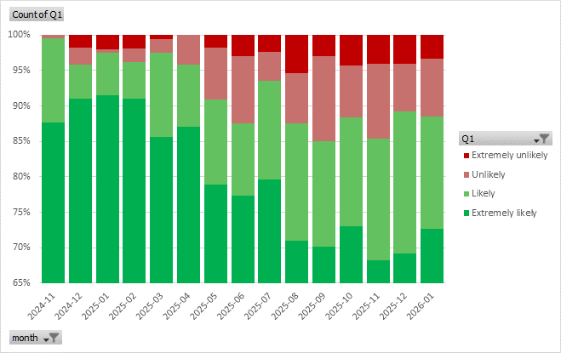
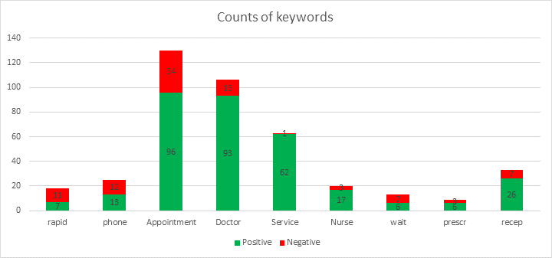

- Correspondence: Joined Up Care Derbyshire (JUCD) etc.

Enid said Mike had submitted an email query. Josta will send to Carolyn for a response.

Rob explained that the National Association for Patient Participation (NAPP) has officially been dissolved, following a vote at the last AGM. See https://napp.org.uk/ to read a message from the Chairman.

Enid has circulated the latest JUCD updates.

- Arrangements for AGM – Revised date 6th March 2026

The AGM will be held on 6th March, and we will have lunch afterwards.

- Mental Health Issues – Adults and Children

No update this period.

- Forward planning and Community events

No update this period.

- Staffing

The Physiotherapist Phil Potter has resigned. The Partners decided not to replace at this time as we already have access to a very good MSK referral service and can use the budget to improve other clinical services.

Mel has joined Mandy as reception leads and 2 new reception team members have been recruited, although one appointment unfortunately fell through. The post has been readvertised.

ANP Vicki is now nurse lead, replacing Liz in that role. She has additional hours in this role to better support the nursing team and has increased capacity.

Dr Sefal Mansoor has joined as a newly qualified GP shared across the PCN and is already garnering very positive feedback.

Doctor Nick Coxon will hopefully be returning in late February.

A new Phlebotomist, Clare, was appointed on 5th February, enabling Overdale to offer blood tests on Mondays, Wednesdays, Thursdays and extended hours on 2 Saturdays per month.

- Proposed committee meeting dates for 2026

6th March (AGM only)
1st May
10th July
4th September
6th November
8th January 2027

- AOB

Carolyn reported there has been an increase in missed appointments (DNAs), and as a result the Practice is introducing a new DNA policy. When an appointment is missed, a letter will be sent to the patient. If this happens 3 times, they will be discussed at a partner meeting and may be removed from the patient list.

The complaints process is being clarified for the benefit of patients. Complaints are received in various ways, the practice will acknowledge within 3 working days, and once investigations have been completed, a formal response will be given. The practice will better advertise how people can complain.

The Chaperone policy is being updated, and a sexual safety charter is being developed. A risk assessment is currently in progress. A Freedom to speak up guardian and wellbeing lead is being assigned to support the team.

Rob enquired if the practice was aware and supporting Jess’ law – an NHS England initiative, introduced in late 2025 following the death of 27-year-old Jessica Brady, that mandates a "three strikes and rethink" approach in primary care. If a patient presents to their GP three times with the same or worsening, unexplained symptoms, clinicians must review, reflect, and consider, such as via specialist referral or face-to-face examination. Carolyn and Andrew were supportive of the initiative, which is currently in the process of being rolled out.

Date of next meeting – AGM on Friday 6th March 2026 at Breaston
To be followed by lunch at the Bull’s Head. Breaston.

