THE OVERDALE MEDICAL PRACTICE

PATIENT PARTICIPATION GROUP (PPG)

MINUTES

Friday 7th November 2025 at 12:00 at the Breaston Surgery

Patient Representatives: Josta Gardner (Chairman), Rob Young (Vice Chairman), Margaret Gregory (Treasurer), Sheila Owens, Sarah Richards, Carol McGuffie, Mike Kerins and new PPG prospective member Valerie Lambert.

Practice Representatives: Carolyn Helm (Practice Manager), Andrew Carson (Assistant Practice Manager) and Dr Thomas Edwards.

Apologies: Enid Ruff (Secretary) and Dr Nick Coxon. Ann Hope was not present and did not send apologies.

Membership: No changes this period.

Approval of minutes (September 2025 meeting).

Approval of minutes proposed by Sarah Richards and seconded by Margaret Gregory.

- Matters arising (from September 2025 minutes).

No matters arising.

- Brief report from the Treasurer

No changes this period.

Balance at September 2025: £196.84
Current Balance: £196.84

PPG funds are held with the Practice. Any expenditure is authorised at the PPG meetings and recorded in the minutes.

- Acceptance of PPG Spending Policy

Copies of the updated PPG spending policy, revised in September 2025, have been circulated to all PPG members. Margaret proposed a motion to accept the revised policy and Sarah seconded. The committee unanimously approved the motion.

- Information Exchange including PPG contribution to the website.

Josta raised an issue concerning the two disabled parking bays at the Borrowash surgery. There are 3 marked bays altogether. When one particular space is occupied, (that is not a parking space at all) it blocks the use of one disabled bay. Carolyn recognised the issue and noted that the previous manager had considered it. Carolyn and Andrew will investigate options to remedy the problem. (Andrew will consult with his cricketing ground staff colleagues!)

- Rapid Health Introduced on 22nd September – Progress Report

Carolyn presented some slides about the implementation of Rapid Health.

She first presented some analysis of appointment data over the last 2 years. Overall demand for appointments has significantly increased whilst at the same time appointment capacity has reduced. The reduction in appointment capacity has been due to GP long term sickness and difficulties in locum provision.

Missed appointments, known as Did Not Attend (DNAs), increased by 50 in 2025 compared to the previous year. This has resulted in more than 105 hours being lost in capacity for patient care. The cause of this is not known, but difficulties in contacting the surgery by phone may well be a contributing factor.

Rapid Health was introduced on 22nd September as a new online system for triage and appointment booking. There have been some ‘teething problems’, some of which are to be expected with any meaningful change, but others that have caused difficulties for patients and the practice.

The algorithm within the system that attempts to triage and prioritise patient need has not been as effective as was hoped. This has led to some appointments being assigned where not necessary (e.g. the patient being better served by pharmacy rather than GP) and others not being given the urgency warranted. This has required intensive review of all requests by GPs and clinicians to ensure patient needs are addressed appropriately.

Rapid Health also appears to have encouraged a patient mindset to request GP services for anything and sometimes even for minor ailments that could be self-managed.

The significant increase in requests, 654, all must be GP reviewed and managed according to urgency. Of these, the number of Red (high urgency) requests stand at 143, Amber (moderate urgency) stand at 250. The high number of red and amber requests indicates a substantial workload for the practice and there are concerns for staff burnout.

Mike asked how patients were being supported if they had difficulty using the Rapid Health system, especially the elderly. Receptionists have been assisting patients by completing the forms online whilst on the phone with them. This has inevitably lengthened average call times and increased call waits. For patients that attend the surgery in person and need help with the system, there is a risk of compromising personal data protection as the reception areas do not have restricted areas for private consultations

The rollout of the online system is part of the national plan that requires all GP practices to offer online access from 1st October and despite the surge in requests, there is currently no ability for GP surgeries to cap or limit the number of requests being issued by the system.

Dr Edwards highlighted a concern that the system does currently not allow requests to see a specific doctor. This means that continuity of care is lost, which can be vitally important for follow-ups and the management of complex cases.

Carolyn presented analysis of appointments by patient age group. There has been an alarming drop in the number of appointments attended by people over the age of 66. This could indicate accessibility issues for the elderly, e.g. use of online systems and longer delays on the telephone etc. There is also a marked increase in the under 12 months having appointments, which could indicate prioritisation of early years care.

Josta asked about how best to inform patients and how the PPG can support patients whilst working through the problems with Rapid Health.
Carolyn explained that the practice is collaborating with colleagues and other practices to get effective solutions in place. She also explained that Overdale is being mandated to have a new web site to match the ‘look and feel’ of the NHS web site. They are also looking at using a simpler online form for non-urgent cases.

- Report on GP clinics, PCN update on Access Plan. New Contract for GPs

No update this period.

- Correspondence: Joined Up Care Derbyshire (JUCD) etc.

Enid has circulated the latest JUCD updates.

- Family and Friends feedback

We discussed the results of the feedback for September 2025 (134 responses), and October 2025 (163 responses).

Patient feedback is generally positive and 87% respondents would recommend Overdale to friends and family (this is down from 90% in the previous period)

The main themes within the positive comments are related to clinical service delivery being exceptionally good and the caring person-centred approach shown by the whole team at Overdale. There continues to be an increase in the feedback of instances where patients are struggling to get an appointment and experiencing long waits on the telephone. However, there is still many patients who say they can get an appointment when they need one. The factors affecting appointment availability telephone waits have been discussed earlier in section 5. It should be noted that this period of feedback (September and October) does not include much in the way of feedback relating to patient experience since the implementation of Rapid Health. This is because most responses received through October will refer to patient experience in September (prior to implementation). There were 11 comments received about the Rapid Health system, and all were negative in nature. Patient feedback received during November will give a much clearer reflection of the impact of the new system.

We discussed a concern raised by a patient regarding medication reviews and repeat medications ‘being removed’ from the system without the patient’s knowledge. Carolyn acknowledged that some work is needed to improve the planning of medication reviews and that if a repeat medication expires, it ‘disappears’ from the NHS app from the patient’s perspective but is still on the system. It was recognised that instances like this causes anxiety for patients and increases phone calls and work for the surgery to resolve.

From the feedback received during September and October, the chart below shows the number of times a keyword associated with various aspects of GP services is mentioned as a positive or negative experience.

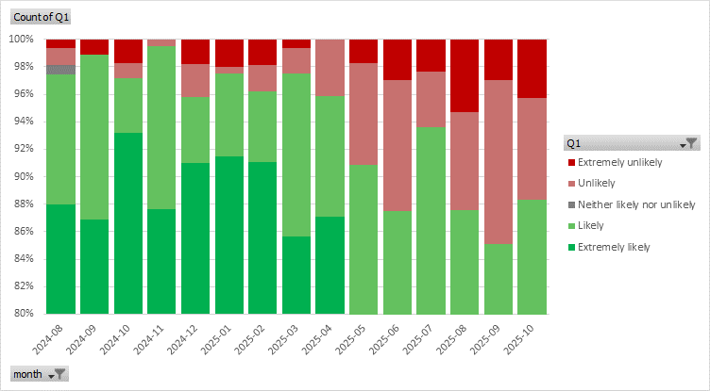

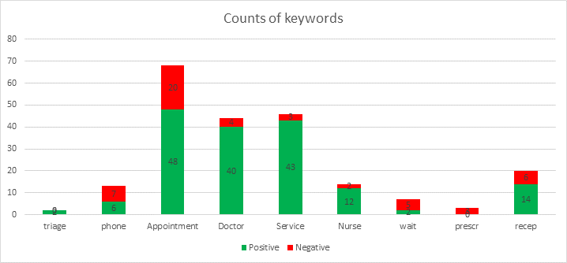

- Mental Health Issues – Adults and Children

No update this period.

- Forward planning and Community events

No update this period.

- Staffing

A new nurse, Megan, will be joining the team in January 2026.

A new secretary, Sally, started this week.

Phlebotomist Lynsey has recently retired, and the practice is struggling to replace, so are planning to bring in locum cover until a replacement is recruited.

Nurse Liz left at the end of October.

There are plans to increase support for the receptionist team through the recruitment of a new reception team leader.

- AOB

None

The next PPG meeting will be at Noon on Friday 9th January 2026 at Breaston.
Seasons Greetings everybody and we will meet again in the New Year!

