THE OVERDALE MEDICAL PRACTICE

PATIENT PARTICIPATION GROUP (PPG)

MINUTES

Friday 1st May 2026 at 12:00 at the Breaston Surgery

Patient Representatives: Josta Gardner (Chairman), Rob Young (Vice Chairman), Enid Ruff (Secretary), Sarah Richards (Treasurer), Julie Bailey, Mike Kerins, Susan Dowey and visitor Jane Ward.

Practice Representatives: Carolyn Helm (Practice Manager), and Andrew Carson (Operations Manager).

Apologies: Margaret Gregory, Valerie Lambert, Sheila Owens, Carol McGuffie and Dr Thomas Edwards. Ann Hope was not present and did not send apologies.

Membership: Sue Dowey was welcomed as new member and Julie Bailey was welcomed a returning member. Jane Ward visited from Derby Road Health centre in Nottingham.

Josta welcomed Jane and shared a copy of the Overdale PPG constitution. Josta gave a brief history of the establishment of the Overdale PPG and explained how the PPG and the Practice work together.
We noted an action to revisit the confidentiality agreements signed by members of the PPG.

Approval of minutes (February 2026 meeting).

Approval of minutes proposed by Sarah Richards and seconded by Carolyn Helm.

- Matters arising (from February 2026 minutes).

Progress of revising the disabled parking lines at Borrowash. Andrew is planning to have this addressed by the end of June. The intent is to maintain the provision of 3 disabled spaces.

Rob passed on his thanks on behalf of Borrowash in Bloom to Overdale for sponsoring a planter this year.

At the last meeting, Carolyn reported an increase in missed appointments (DNA’s). The practice is now contacting DNA patients by letter and starting a warning process of up to 3 times over a rolling 12 months. This will lead to a discussion at a partner meeting for risk assessment and potentially asking the patient to leave the practice. A contributing factor is thought to be longer term appointments (eg 28 days) where the need for the appointment may go away or simply be forgotten. The upgrade to the phone systems should better enable people to cancel unwanted appointments by leaving a message.

- Brief report from the Treasurer

Margaret Gregory has resigned as Treasurer and Sarah Richards was elected at the AGM held on 6th March 2026.

There have been no transactions this period.

Balance in February 2026: £196.84
Current Balance: £196.84

PPG funds are held with the Practice. Any expenditure is authorised at the PPG meetings and recorded in the minutes.

- Information Exchange.

Carolyn gave an overview of Abtrace software to aid the management of long term conditions.

This software helps to better support patients with long term or complex conditions and helps planning of interventions and follow-ups. The software will reduce the administrative burden and free up resources to proactively follow up with patients where needed. The system is currently being trialled.

Sue asked about whether or not the practice can use volunteers to assist in certain administrative tasks. Andrew explained how once set up, most of it is automated.

- Adjustments to Appointment system. Progress report after one month

The nationally implemented Rapid Health on-line triage and booking system has been problematic for patients and staff at Overdale, so the practice has recently implemented its own non-urgent appointment booking system.

Andrew explained that the new system went live on Monday 30th March. Complaints are noticeably down when compared to the previous system. The practice has made several minor updates in response to patient feedback.

The on-line system is only intended for booking non-urgent appointments. If a patient indicates a potentially urgent problem, they will be directed to contact the surgery by telephone.

It is an ICB requirement to provide an online booking system, numbers are uncapped and need to be acknowledged within a certain timeframe. The practice is currently receiving an average of 120+ requests on a typical Monday and approximately 60 on a Friday.

The waiting list is processed every morning and appointments are offered up to 14 days in advance.

- Family and Friends feedback

We discussed the results of the feedback for February 2026 (212 responses) and March 2026 (256 responses).

Patient feedback is very positive, and 93% respondents would recommend Overdale to friends and family (a 7% improvement since the previous period).

The main themes within the positive comments are related to clinical service delivery being exceptionally good and the caring person-centred approach shown by the whole team at Overdale.

There continues to be incidents where patients have reported difficulty in obtaining appointments, but the vast majority of positive comments praise the surgery about being able to get an appointment when needed.

There are still some negative reports about the Rapid Health non-urgent online booking system. The new replacement system went live at the end of March, we will not see patient feedback for this until we review feedback received in May onwards.

Sarah had observed and heard from other patients anecdotally that the patient waiting rooms often appear empty. This is largely as a result of improved time management for appointments but can give the impression that the practice isn’t busy. Carolyn said she will consider how this could be communicated to patients.

From the feedback received during February and March, the charts below show the overall patient satisfaction and the number of times a keyword associated with various aspects of GP services is mentioned as a positive or negative experience.

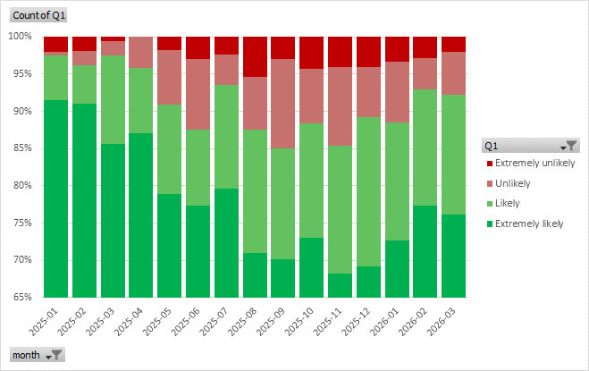
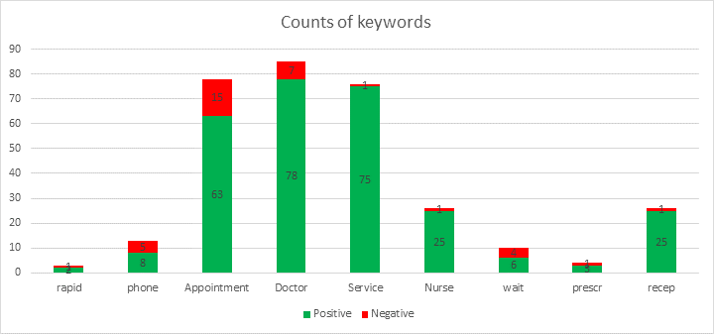

- Correspondence: Joined Up Care Derbyshire (JUCD) etc.

Enid has circulated the latest JUCD updates.

Enid thanked members of the PPG for acknowledging receipt of information.

- Mental Health Issues – Adults and Children

From 1st July the 0800 number for mental health is being discontinued and those services will be accessed through 111.

- Forward planning and Community events

No update this period.

- Staffing

Dr Ludlow is leaving at end of May to join another Practice in Melton Mowbray. The practice and PPG wish her well.

Dr Ogunlusi is leaving at end of June, to emigrate to Australia.

Molly is on maternity leave and Abbie has joined to take on her role.

The practice is currently advertising the post of assistant practice manager.

Nurse Megan has left due to commuting difficulties.

The Practice is looking to employ a Healthcare Assistant to assist with pre-checks and enable more time with the nurses.

- AOB

Mike asked about the involvement of the practice in research projects. Carolyn explained Overdale is currently at level 1 and plans to remain at this level while the practice stabilises and adjusts to the significant changes over recent months.

Sue asked about quality standards framework. Carolyn explained there has been a lot of change and this would certainly be something to work towards and some of these aspects are encompassed with CQC compliance.

Date of next meeting – Friday 10th July 2026 at the Breaston Surgery

