THE OVERDALE MEDICAL PRACTICE

PATIENT PARTICIPATION GROUP (PPG)

MINUTES

Friday 17th July 2026 (re-scheduled from 10th July) at 12:00 at the Breaston Surgery

Patient Representatives: Josta Gardner (Chairman), Rob Young (Vice Chairman), Sarah Richards (Treasurer) and Ann Hope.

Practice Representatives: Carolyn Helm (Practice Manager) and Dr Thomas Edwards

Apologies: Margaret Gregory, Valerie Lambert, Sheila Owens, Carol McGuffie, Enid Ruff (Secretary), Julie Bailey, Mike Kerins, Susan Dowey and Andrew Carson (Operations Manager).

Membership: No changes this period.

Approval of minutes (May 2026 meeting).

Approval of minutes proposed by Sarah Richards and seconded by Carolyn Helm.

- Matters arising (from May 2026 minutes).

Progress of revising the disabled parking spaces at Borrowash. This is ongoing and Andrew is in discussion with a contractor. The intention is to increase the provision from two disabled spaces to three (in the front of the surgery premises).

Missed appointments (DNAs) continue to be a problem but recently the practice has introduced a telephone option for cancelling an appointment without queueing. This should make it easier for patients to cancel appointments when they are no longer needed.

- Brief report from the Treasurer

There have been no transactions this period.

Balance in May 2026: £196.84
Current Balance: £196.84

PPG funds are held with the Practice. Any expenditure is authorised at the PPG meetings and recorded in the minutes.

- Overdale Vision and Mission Statement

Carolyn summarised the output from recent work to develop the mission statement, vision and core values of Overdale Medical Practice. This document had been circulated to members of the PPG for feedback.

We discussed the feedback submitted by Julie. The consensus of the group was that the current wording in the document sufficiently recognised the role of all the staff and was developed in collaboration with them. The PPG agreed that the document, as presented, is very good.

- Information Exchange.

Nothing to report this period.

- Adjustments to Appointment system. Progress report after three months

Carolyn provided some data about the online non-urgent requests since the system was introduced at the end of March.

Almost 5000 requests were submitted in April, May and June. Processing this number was very difficult and at one time there were more than 800 requests awaiting a response. Doctor capacity has been impacted due to some leaving and delays in recruitment. Locums are being used to bridge the shortfall, and the outstanding requests have been reduced.
To tackle the backlog of non-urgent requests, the number of urgent, same-day appointments has been reduced and patients, on occasions, have been signposted to other urgent same-day services.

Tom summarised a study by Nick Malone to analyse appointment capacity over time at Overdale. The analysis compared September 2022, September 2025 and future projected capacity. It showed that the number of individual GP appointments had reduced since 2022 (by 860 per month), but the overall clinical time available to patients had increased (by 66 hours per month). This is because appointments are now longer, allowing clinicians more time to address patient needs, and because the practice is making greater use of the wider clinical team, including Advanced Nurse Practitioners.

Rob raised a concern that although individual appointment time and clinical hours have increased, the number of appointments in real terms have significantly decreased whilst at the same time patient numbers and demand has increased. The patient feedback is showing clearly that patients are increasingly struggling to get appointments and are having long waits on the telephone.
Carolyn explained that patient numbers had increased, but not significantly, although specific patient numbers were not included in this analysis.

The key factors thought to be driving the increased demand on GP services are the Advice and Guidance initiative and the knock-on effects of delays in secondary healthcare services, requiring greater GP interventions to support patients who are waiting for specialist services.
Advice and Guidance was introduced which is putting more pressure on primary care to manage interactions with specialists and the patient which would have previously been conducted through secondary healthcare referrals – this was a government initiative to reduce hospital waiting lists, but has significantly increased demand on primary care (and without adequate funding)

Tom explained that there is also a balance of quantity and quality, hence the need to increase appointment times and the current churn in key clinical staff levels is impacting capacity. There are physical room capacity limits as well as clinicians themselves and the practice is operating close to maximum capacity.

The demand per patient has increased from 17 to 19.1 hours since 2022. GP services are having to manage conditions and symptoms for longer because of delays elsewhere in the healthcare system. Some conditions, ADHD as an example, have very much increased demand for GP services. In conclusion, most of the increase in patient demand for GP services is not so much about patient numbers increasing, but due to increasing demand from the same number of patients and knock-on effects of delays elsewhere in the healthcare system.

Carolyn explained that the practice continues to work extremely hard to maximise ease of access to GP services, despite the increasing challenges all GP surgeries are facing.

- Family and Friends feedback

We discussed the results of the feedback for April 2026 (170 responses), May 2026 (172 responses) and June 2026 (170 responses).
Patient feedback is generally positive, and 88% of respondents would recommend Overdale to friends and family (a 5% decline since the previous period).

The main themes within the positive comments are related to clinical service delivery being exceptionally good and the caring person-centred approach shown by the whole team at Overdale.

There continues to be incidents where patients have reported difficulty in obtaining appointments, and significant queues on the telephone, but most positive comments praise the surgery about being able to get an appointment when needed.

Feedback regarding online system to raise non-urgent requests continues to be mixed. As mentioned earlier, there has been significant effort by the practice to address the backlog of requests.

From the feedback received during April, May and June 2026, the charts below show the overall patient satisfaction and the number of times a keyword associated with various aspects of GP services is mentioned as a positive or negative experience.
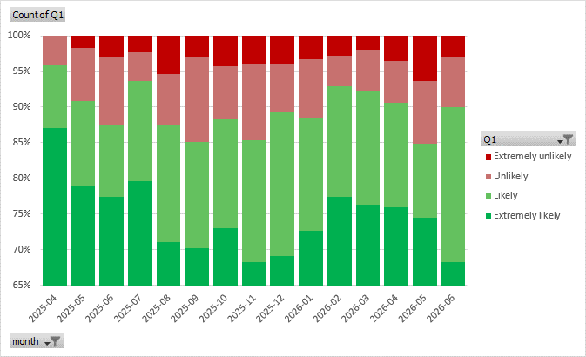

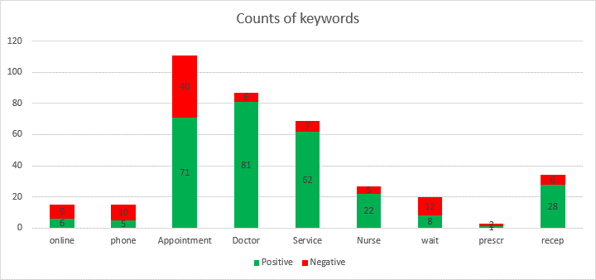

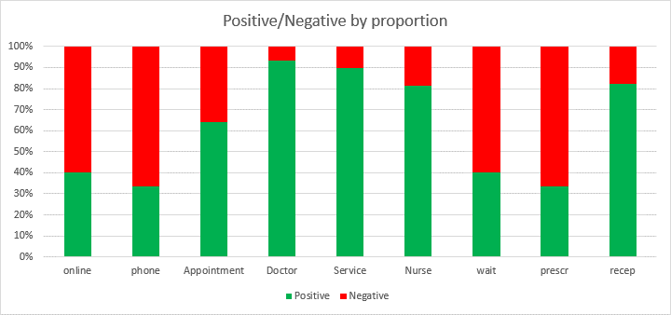

- Correspondence: Joined Up Care Derbyshire (JUCD) etc.

Enid has circulated the latest JUCD updates.

- Mental Health Issues – Adults and Children

No update this period.

- Forward planning and Community events

No update this period.

- Staffing

The practice has recruited a Healthcare Assistant, Collette, starting in September to assist with wound care, vaccinations, tests and patient pre-checks.

Suzanne the long term conditions nurse has left and the practice is trying to recruit, currently using a locum.

The practice is also recruiting an assistant manager.

Phlebotomy services at the practice have been increased to 3 times a week and every other Saturday.

- AOB

Nothing to report.

Date of next meeting – Friday 4th September 2026 at the Breaston Surgery

